Demo of U4328A – M.2 Interposer.

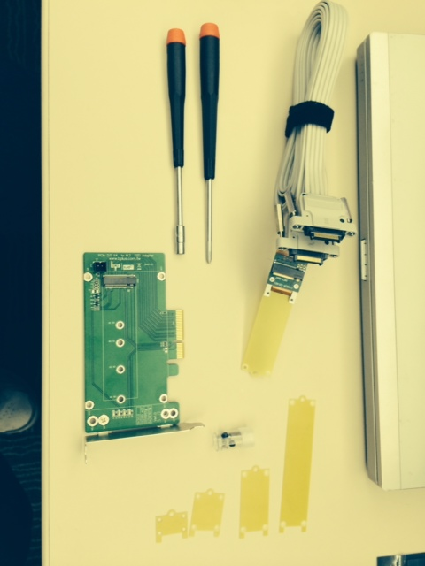
Parts included in the interposer.
Cable with attached interposer.
Mounting bases for
- 2230
- 2238
- 2242
- 2260
- 2280
Screws and mounting standoff.
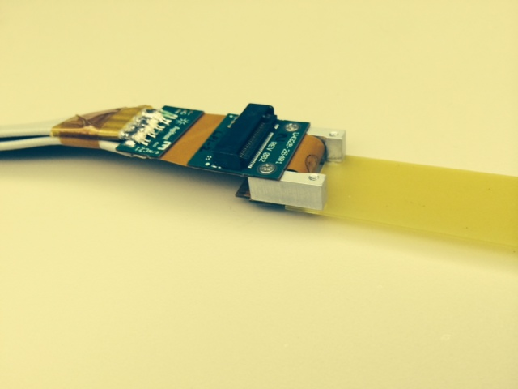
(M.2 to CEM adapter NOT included)
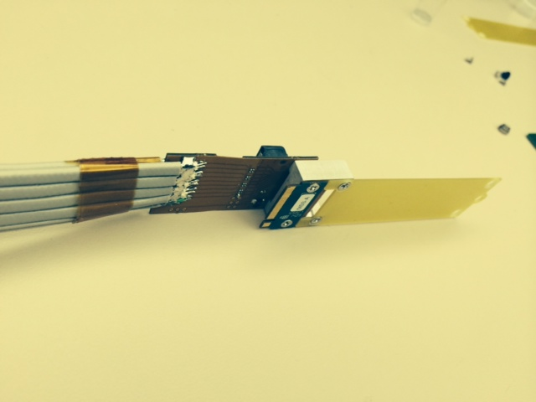
Top View of U4328A
Interposer Socket3 (M-key)

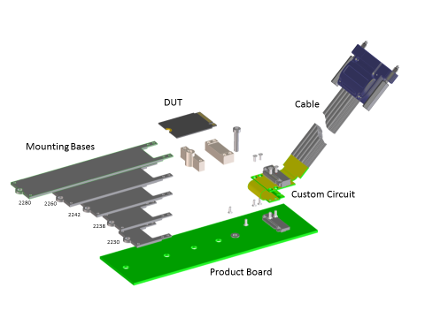
Bottom view of U4328A

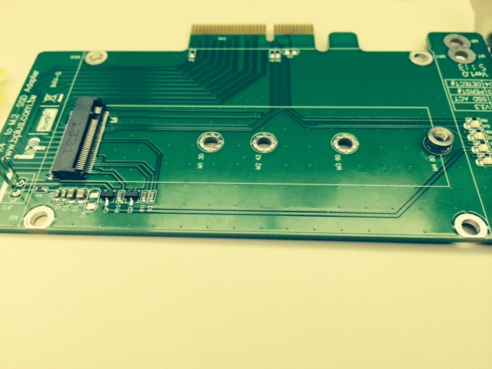
M.2 adapter (Bplus Technologies of Taiwan)
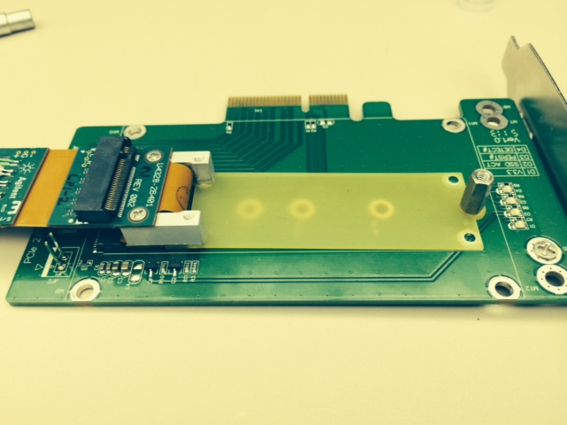
Install Interposer on host system. Screw down with standoff screw.

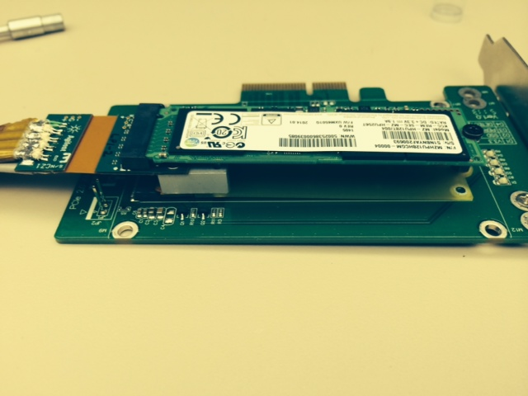
Install SSD with standard hardware. Connect cable to analyzer.
Analyzer configuration
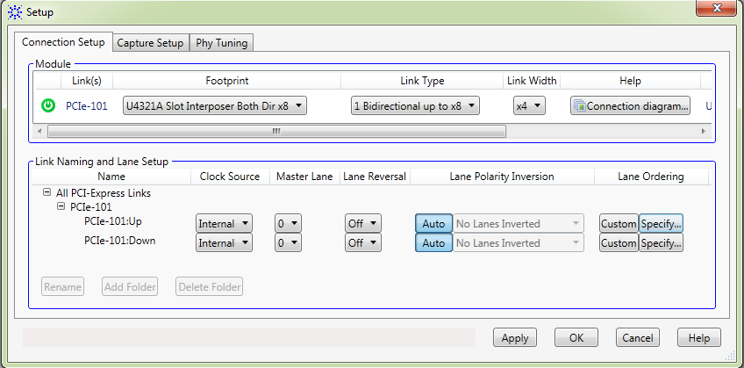
In setup, Use U4321A Slot Interposer with bi-directional and x4 configuration.
For Lane Ordering, specify a custom configuration. Advanced.

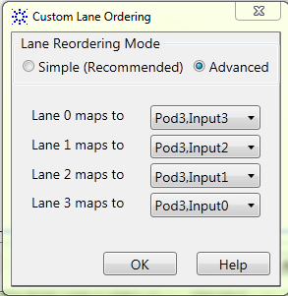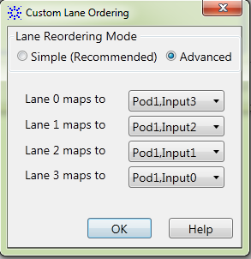
Upstream Downstream
(Reversed order on Pod 3) (Reversed order on Pod 1)

Specifications
Input Impedance and capacitance | Differential Input R: 250 Ohms to ground per side  Differential Input C: 0.33 pF
Scope Probe connections supplied | CLREQ#, PERST#, PEWAKE#
Power probe resister value | 50 mOhms (for use with N2820A)
Adapter Height | 12.8 mm
Cable length | 1 meter (39.4 inches)
Supplied adapters | 2230, 2242, 2260, 2280, and 22110

